WIFI CONFIGURATION USING NRF CONNECT MOBILE APP:

Download and Install the NRF connect app from the google play store
Open the app
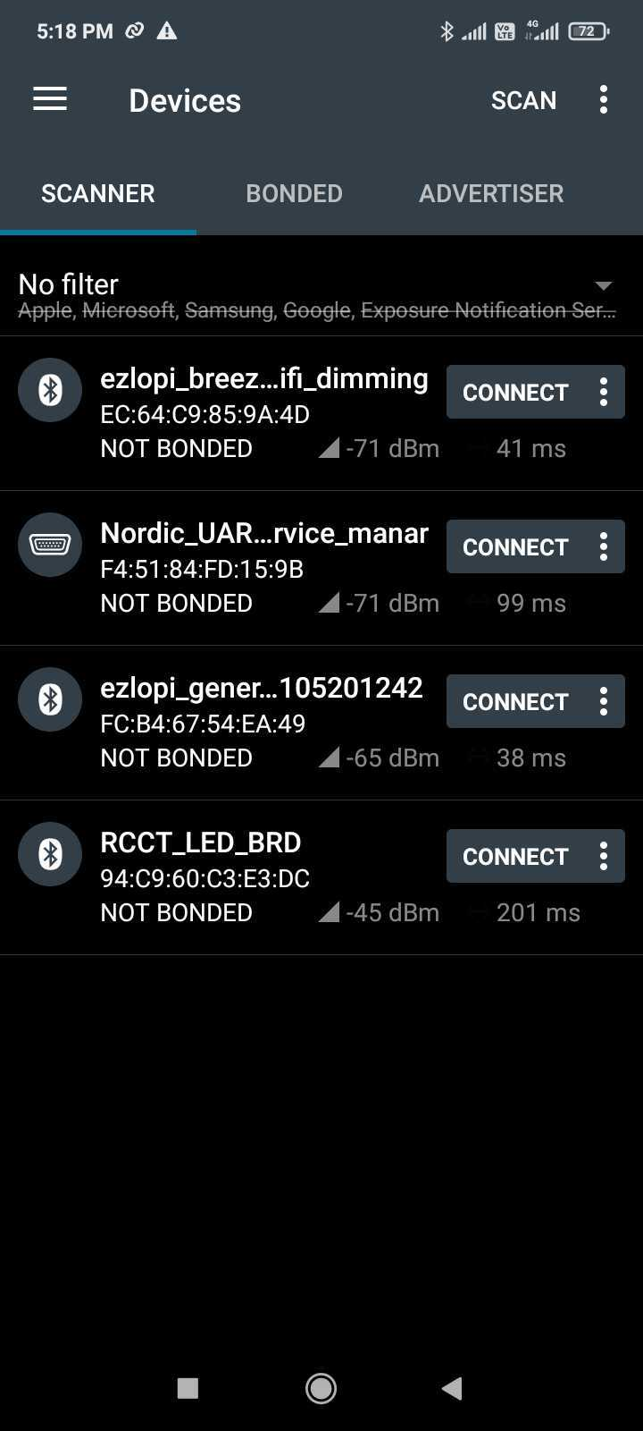
press the scan button and the RCCT_LED_BRD will show up in the scanners tab . connect to the RCCT_LED_BRD

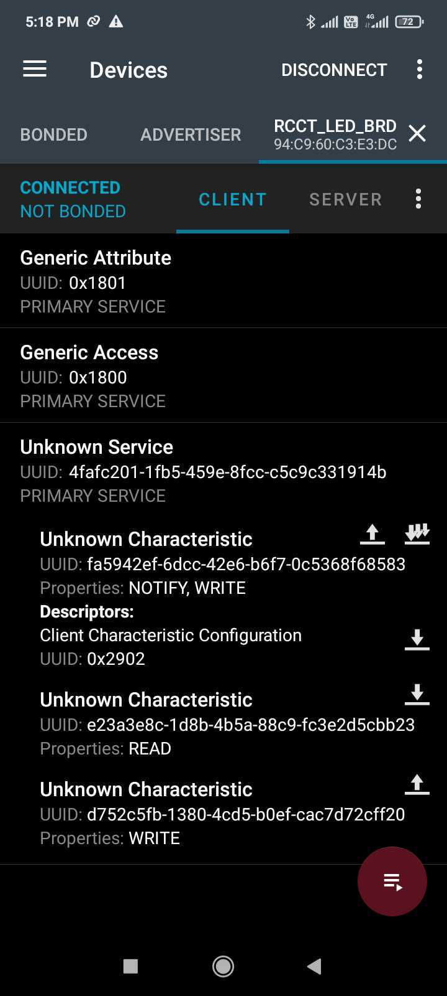

Click on the third characheteristic (write charachteristic)
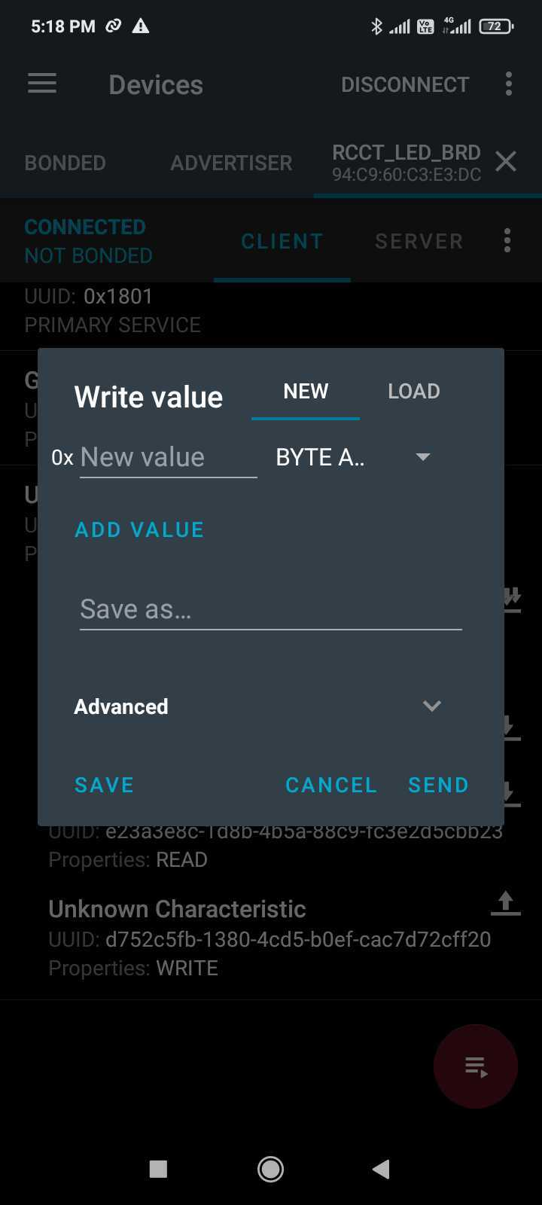

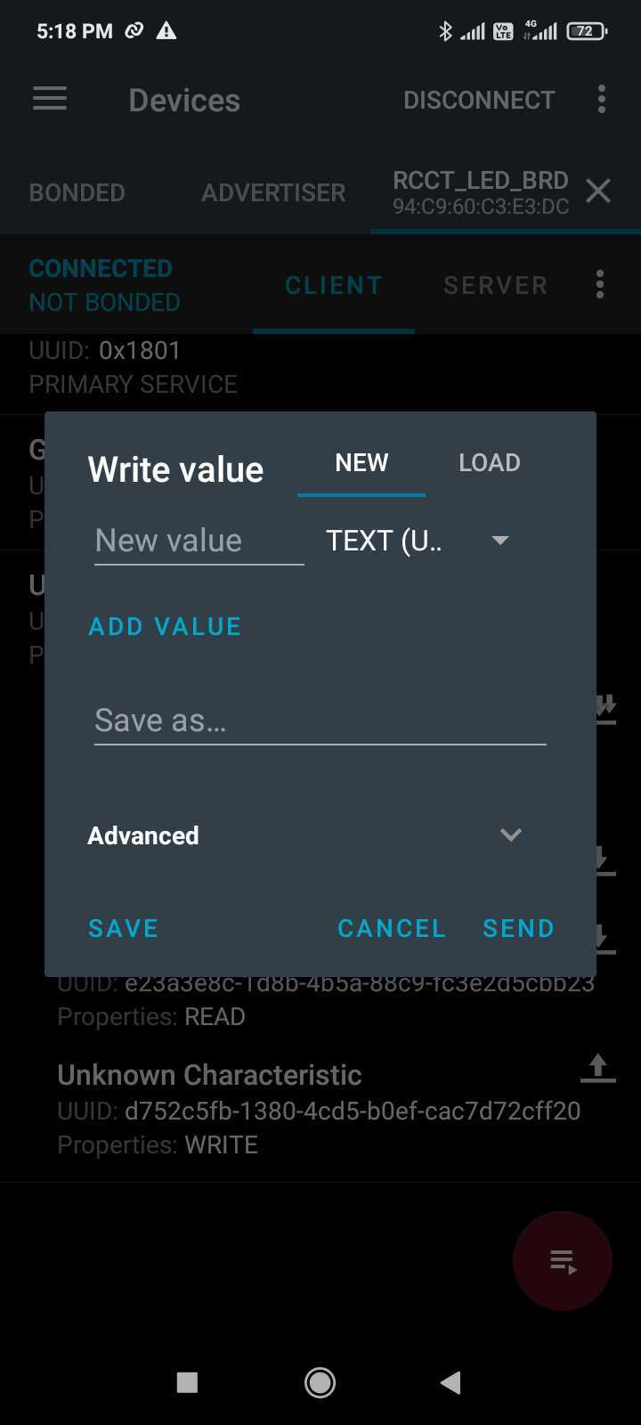
Change the type of value to text

Now paste the wifi creds JSON which goes as:
{"ssid": "your_ssid", "password": "your_password"}

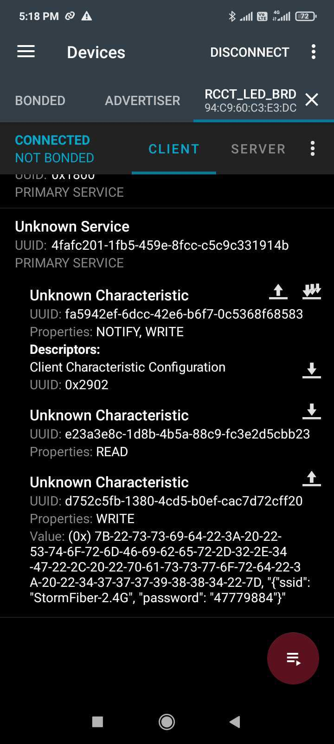
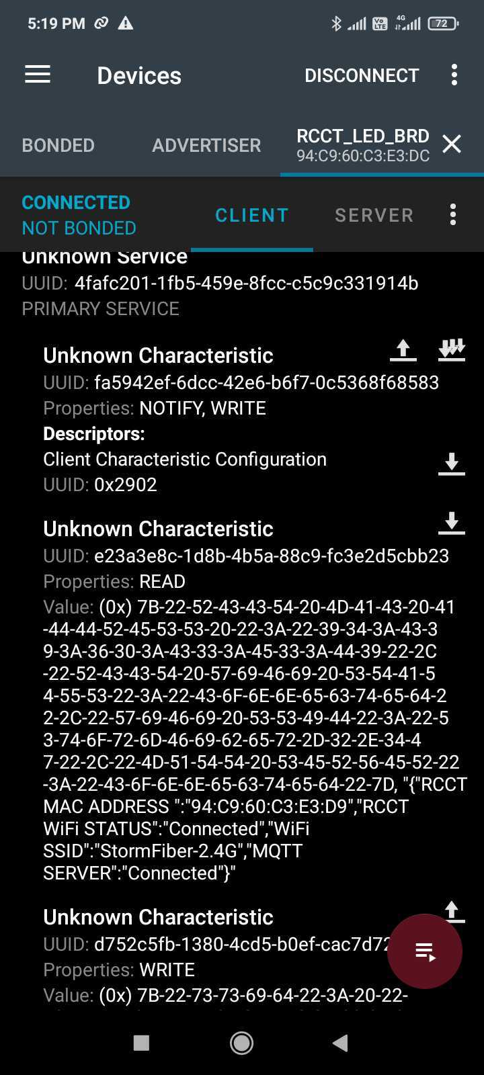
after entering and sending the JSON it will look something like this:
inorder to verify if the JSON is sent you can click on the read characteristic arrow and it will show the device connectivity status

